Crowd Funding Exercise

Michael Lambert

3/5/23

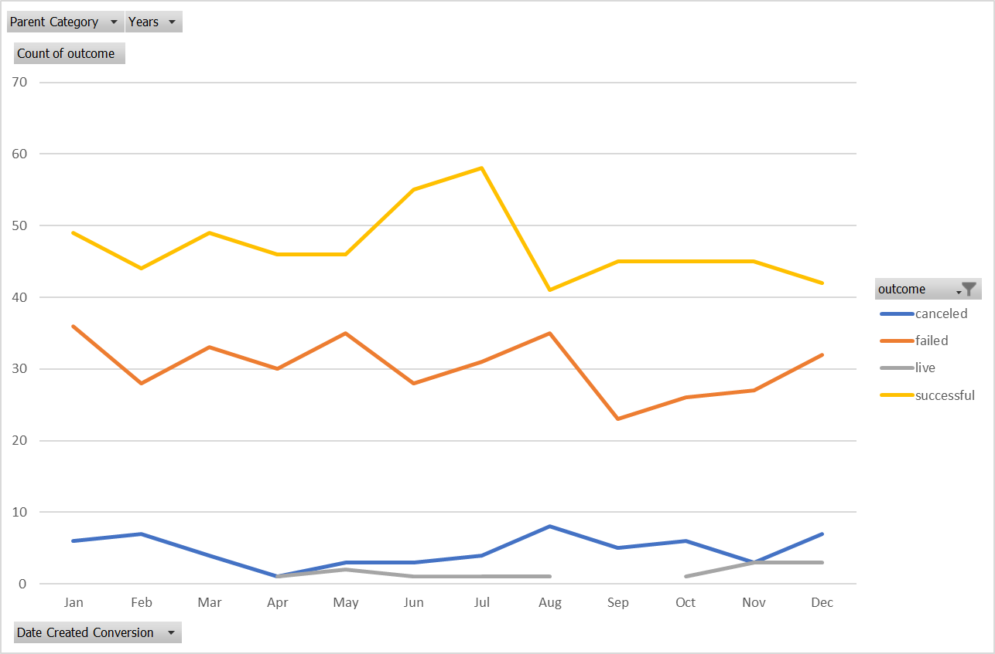

1. Given the provided data, what are three conclusions we can draw about crowdfunding campaigns?
   1. In general more campaigns were successful than failed
   2. If someone started a crowdfunding campaign they are likely to cancel it
   3. There does seem to be a specific month where it is more advantageous to start a crowdfunding campaign than others
   4. Data has been collected over a ten year period
2. What are some limitations of this dataset?
   1. It is only 1,000 projects and we have no idea how many there actually were
   2. There is data from only seven countries. Is this the only place where you can do a kick starter? Were others excluded for a reason?
3. What are some other possible tables and/or graphs that we could create, and what additional value would they provide?
   1. Charts: Was it a staff pick?
      1. If it was/was not a staff pick what effect did that have on the overall success of the project?
   2. Compare date created and date ended. Are crow funded projects with a longer “live” time more or less successful?